چکیده گرافیکی

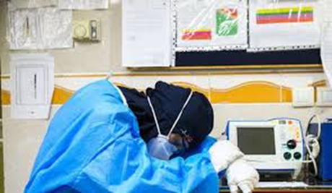

**Background:** Considering the key role of faculty members in educating students, assessing the burnout of faculty members in medical universities is essential. Understanding their status helps officials make effective decisions, improve the quality of work life, and increase effectiveness. This study determined the level of burnout among faculty members at MAZUMS.

**Methods:** This study included 125 faculty members selected via convenience sampling. A burnout questionnaire included emotional exhaustion, depersonalization, and personal failure with reliability of 0.82. Data were analyzed using mean, standard deviation, Mann-Whitney, and Wilcoxon tests.

**Marriage**

**Gender**

**Faculty**

**Academic rank**

**Degree**

**Employment type**